JANUARY PreSchool Classroom Leader

These are the general expectations for you as a small group / classroom leader in PreSchool:

- Please wear your volunteer T Shirt when you serve. If you don’t have one, I will get you one this Sunday to wear for future weeks.
- All volunteers will be given a background check request form and a volunteer profile form to complete. If possible, this will be done prior to serving. If not, it will be given to you when you serve the first time.
- Arrive and check in by 10:30. You will be set up to check-in as a volunteer in our system and will receive a label to wear to identify yourself to parents.
- If there is not Sunday school still going on in your classroom, go to your room and get out supplies to start the first activity.
- All volunteers should arrive prepared having reviewed the curriculum ahead of time. Even if one volunteer acts as the lead teacher, the 2nd volunteer should know the materials in order to help with activities and to help find teachable moments during class time. The focus should be on the children and not on reading the materials for the first time.
- The “4 minute parent perspective” is a term that refers to the 2 minutes that parents are at the room for drop off and again for check out. What they observe and perceive during these 4 minutes sets their expectations for what happens when they are away. At least one volunteer per classroom should be ready to greet the preschoolers and parents as they arrive while the other volunteer makes sure the children are playing and being engaged quietly. There is a PreSchool praise DVD in drawer B or on the DVD player shelf that can be played at a low volume to engage those kids who aren’t interested in play or just to add background sound.

The following is a general overview of the flow of the morning and how the curriculum is to be used. Specific things that apply to this month are in RED.

- If you have not received volunteer folders, they will be provided in the room. These should be taken home for preparation before the next week.
- The online document is in Word format. The folders include only the activities you will lead each week . There may be a handwritten note with S (Sunday) or W (Wednesday) to indicate when the activity will be used. The format printed is a PDF which includes additional key information for you at a glance (Basic Truth, Bottom Line, Memory Verse, etc.) on each page and each activity has it’s own page. This format will also tell you the focus/kind of activity each one is. I use a variety of criteria in choosing which activities we do each week and overall I try to mix up the type of activity across the month. This helps all kinds of learners understand what is being taught and helps hold the interest of preschoolers.
- All resources for the activities have been prepared and are ready in the room. Drawer B contains supplies specific for the current day’s activities as well as take home items for each child. Drawer C contains every day items such as glue sticks, crayons, etc. There are 2 containers of all of these staples, one for each table.
- We use a curriculum called First Look which uses a small group/large group teaching format. We use our classrooms to lead the small group activities and take our 3 – 5 year olds to our “Clubhouse” for large group time. Here the kids are introduced to a memory verse with motions, worship and a short video teaching. These formats allows volunteers to choose what they are gifted to do – lead “up front” or teach kids in smaller groups for activity times.
- The opening activities in the classroom are grouped under a heading called Social. There will be 2 and sometimes 3 activities that I have chosen for use prior to large group time. This time is for engaging and getting to know the kids and introducing them to concepts to be taught later. These activities can be used during arrival time but most leaders prefer to lead them with all the kids after most have arrived by 10:45.
- The activities for after large group are called Groups. These activities reinforce what the kids learned from large group and continue helping them put into practice what they learned. They are called groups so that they can be done in smaller groups of kids either at each table or around the room with the same group leader with the same kids each week.
- Sara Oelke will be the large group leader and team coach for week 1 & 2. Allison Davis will be the leader the remainder of the month. They will let you know when it’s time to go to the clubhouse for large group worship and teaching. This will be at approximately 11 a.m. After large group, they will also bring you ice water for snack time.
- During Large Group, it is preferable for you to sit with your kids – on the floor or in chairs, depending on what the large group leader has planned. The kids should sit beside you, not in your lap. Help them stay focused and paying attention to the large group leader as much as possible. When they stand to sing or learn the memory verse motions, model the behavior and participation you want to see. During this large group time, it’s your responsibility to manage behavior of your kids as much as possible so the large group leader can concentrate on presenting her part of the day’s activities.
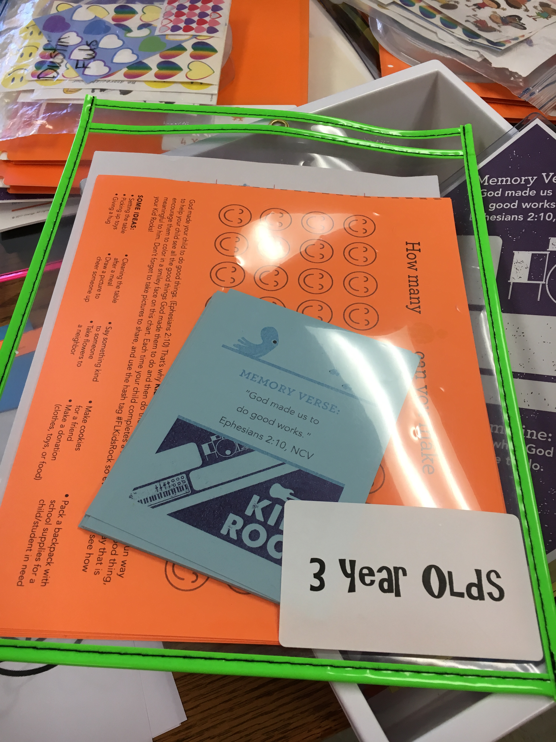
- When parents start coming after the service, ask for the checkout sticker and attach it to the checkout report hanging on your classroom door. Don’t forget to send home any personal items, crafts the kids have made and the documents left for you in the clear folder with bright binding. You should find the monthly Parent Cue and the Memory Verse card in this folder. Send them home the following weeks to kids who are attending for the first time this month. The GOING HOME document in your folder and also online for your preview will give you CUES to say to the parent about what their kids learned this week, etc.
- As you prepare to leave, gather the checkout sheet with labels attached, the clear folder and the white bin from drawer B and the water pitcher and drop them off in Volunteer Central on the large table. Write a note on the checkout sheet if you have concerns, needs or ideas to share with me.

THANK YOU! You are making a difference with our kids! Relationships are MOST important with our kids – loving them like Jesus even when it’s hard sometimes! See you again Next Week! I also look forward to hearing how things went for you and anytime you have ideas to make things better – just text me!

Bev Austin

